**Course: Statistical and Predictive Modeling**

**Assignment 3: Advertising Analysis**

**Submitted by: Maisha Khatoon**

**Student ID: 100899259**

**Submission Date: 28/02/2024**

Contents

Questions 2

1. The Hypothesis Statement (by using an ‘if’ statement) that helps solve the research question 2

2. Step-by-step outline (in a total of 5 steps) on how I proved the hypothesis statements 2

Stating my Hypothesis Statement 2

Specifying the Significance Level 2

Conducting a one-sample t-test 2

Analyzing test results 2

Conclusion based on the test results. 2

3. Conduction of the analysis that I outlined in #2 in R 3

4. Findings and Conclusion 3

Summary of findings 3

Conclusion 3

# Questions

## 1. The Hypothesis Statement (by using an ‘if’ statement) that helps solve the research question

If the average sales for Ad2 are more than 55,000 units per week, then there is evidence that Ad2 has a greater impact on the sales of Samsung than Ad1.

## 2. Step-by-step outline (in a total of 5 steps) on how I proved the hypothesis statements

### Stating my Hypothesis Statement

Null Hypothesis: Null Hypothesis is denoted as H0.

The Null Hypothesis for this case states that the mean sales remain at 55,000 units, i.e. H0: μ ≤ 55,000.

Alternative Hypothesis: Alternative Hypothesis is denoted as H1.

The Alternative Hypothesis for this case states that average weekly sales differ from 55,000 units, i.e. Ha: μ > 55,000.

Where μ is the true average weekly sales for Ad2.

### Specifying the Significance Level

The significance level (alpha or α) is typically 0.05, indicating a 5% chance of incorrectly rejecting the null hypothesis.

### Conducting a one-sample t-test

A one-sample t-test has been conducted to compare Ad2's mean sales to the known population mean of 55,000 units. This test calculates whether the transition to Ad2 significantly alters average sales.

### Analyzing test results

Based on the one-sample t-test, the return value for the p-value is = 0.1913. This means that the p-value exceeds the significance level (alpha or α) i.e. α = 0.05.

As a result, the Null Hypothesis is not rejected.

### Conclusion based on the test results.

From the t-test result that is conducted, the Null Hypothesis cannot be rejected.

This indicates that the evidence that is provided to support the claim that switching from Ad1 to Ad2 enhances the mean sales of the Galaxy S23 Ultra is insufficient.

## 3. Conduction of the analysis that I outlined in #2 in R

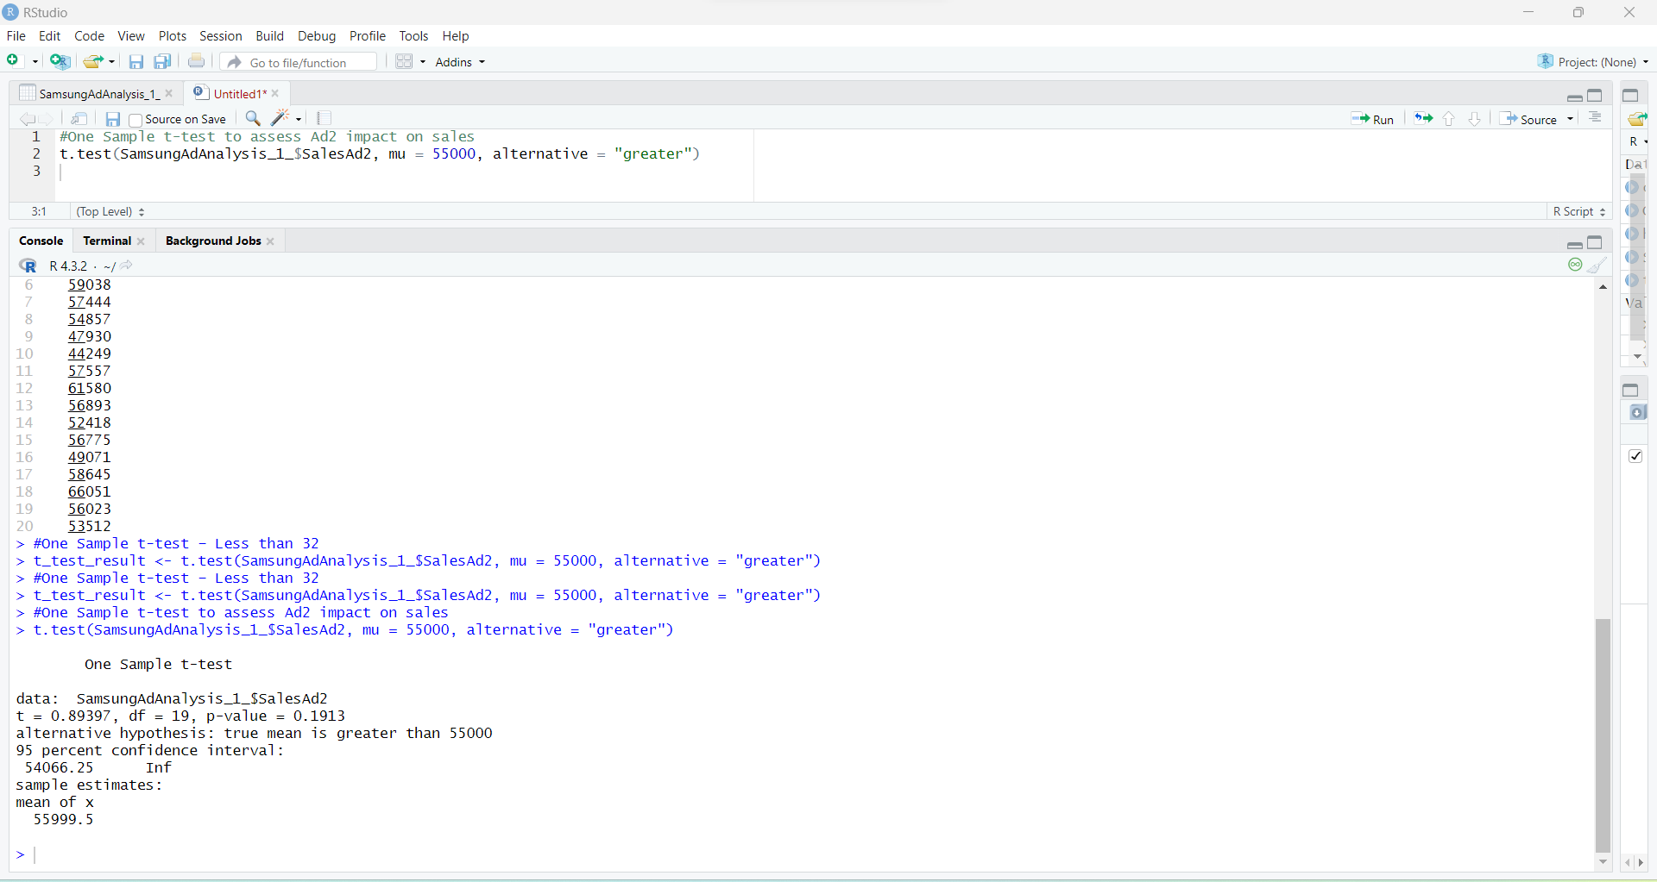

## 4. Findings and Conclusion

### Summary of findings

A one-sample t-test was used to assess the average weekly sales of Ad2 to 55,000 units. The null hypothesis proposed that the genuine population mean sales for Ad2 are less than or equal to 55,000 units. The alternative hypothesis indicated that the mean was more than 55,000 units. At a significance level of 0.05, the statistical test's p-value exceeded the alpha barrier. As a result, there is not enough proof to reject the null hypothesis, which states that Ad2's mean weekly sales are 55,000.

The sample data does not definitively show that the new Ad2 campaign relates to an increase in average weekly sales compared to Ad1 results. While the Ad2 mean sample sales exceeded 55,000 units, the t-test results indicate that the difference is not statistically significant.

### Conclusion

The intended result of a conclusive increase in weekly sales volume of Samsung Galaxy S23 Ultra smartphones over what was previously observed from Ad1 alone has not been attained by the ad campaign containing Ad2. If real gains can be linked to Ad2, more information or testing could be required. Samsung will have to think about tweaking some of the new marketing campaigns, looking into different strategies, and keeping an eye on outside variables that affect consumer behavior. Although the existing data does not conclusively indicate success, it is still unclear if the strategic advertising transition to Ad2 would result in a sales increase with additional refinement.